Banking Loan & Risk Analysis
Project Title - Banking Loan & Risk Analysis using MySQL, Python and Power BI
--------------------SQL--------------------
- ERR Diagram –

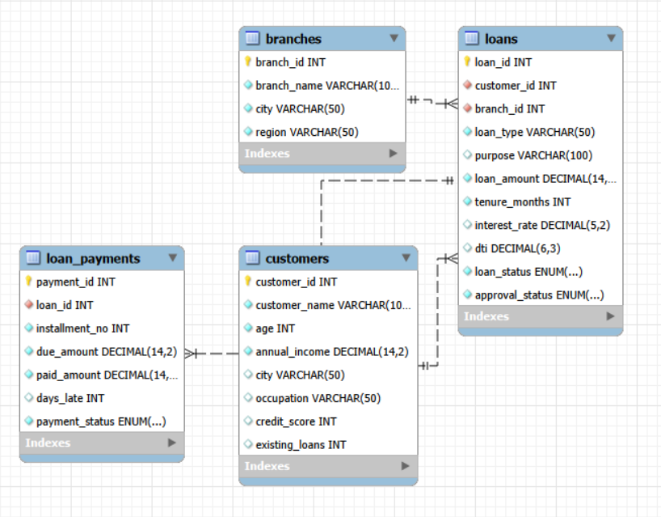

- Creating Database –
create database if not exists banking_risk_analytics;

- Use Database –
use banking_risk_analytics;

- Create Tables –
- Branches –
create table branches (
branch_id INT PRIMARY KEY,
branch_name VARCHAR(100) NOT NULL,
city VARCHAR(50) NOT NULL,
region VARCHAR(50) NOT NULL
);

- Customers –
create table customers (
customer_id INT PRIMARY KEY,
customer_name VARCHAR(100) NOT NULL,
age INT NOT NULL,
annual_income DECIMAL(14,2) NOT NULL,
city VARCHAR(50),
occupation VARCHAR(50),
credit_score INT,
existing_loans INT DEFAULT 0
);

- Loans –
create table loans (
loan_id INT PRIMARY KEY,
customer_id INT NOT NULL,
branch_id INT NOT NULL,
loan_type VARCHAR(50) NOT NULL,
purpose VARCHAR(100),
loan_amount DECIMAL(14,2) NOT NULL,
tenure_months INT NOT NULL,
interest_rate DECIMAL(5,2),
dti DECIMAL(6,3),
loan_status ENUM('Active','Closed','Defaulted') NOT NULL,
approval_status ENUM('Approved','Rejected') NOT NULL,
FOREIGN KEY (customer_id) REFERENCES customers(customer_id),
FOREIGN KEY (branch_id) REFERENCES branches(branch_id)
);

- Loan_payments –
create table loan_payments (
payment_id INT PRIMARY KEY,
loan_id INT NOT NULL,
installment_no INT NOT NULL,
due_amount DECIMAL(14,2) NOT NULL,
paid_amount DECIMAL(14,2) NOT NULL,
days_late INT DEFAULT 0,
payment_status ENUM('On Time','Late') NOT NULL,
FOREIGN KEY (loan_id) REFERENCES loans(loan_id)
);

- Count All Tables –
select count(*) from customers;
select count(*) from loans;
select count(*) from loan_payments;
select count(*) from branches;

- Check Bank Loan Overview –
select count(*) as total_loans,
sum(loan_amount) as total_loan_value,
avg(loan_amount) as avg_loan_amount
from loans
where approval_status = 'Approved';

- Check Default Rate –
select round(100 * sum(loan_status = 'Defaulted') / count(*) , 2 ) as Default_rate
from loans
where approval_status = 'Approved';

- Types Of Loan Portfolio –
select loan_type,
count(*) as loans,
sum(loan_amount) as total_amount,
avg(loan_amount) as avg_amount
from loans
where approval_status = 'Approved'
group by loan_type
order by total_amount desc;

- Check Risk By Credit Score –
select case
when c.credit_score < 600 then 'Poor'
when c.credit_score < 680 then 'Fair'
when c.credit_score < 750 then 'Good'
else 'Excelent'
end as credit_band,
count(distinct l.loan_id) as loans,
round(100 * sum(l.loan_status= 'Defaulted') / count(*) , 2) as Defaulte_rate
from customers c
join loans l on c.customer_id = l.customer_id
where l.approval_status = 'Approved'
group by credit_band
order by Defaulte_rate desc;

- DTI Risk –
select case
when DTI > 0.50 then 'High DTI'
when DTI > 0.35 then 'Medium DTI'
else 'Low DTI'
end as DTI_bands,
count(*) as loans,
round(avg(DTI), 3) as Avg_DTI,
round(100 * sum(loan_status = 'Defaulted')/ count(*) ,3) as Defaulte_rate
from loans
where approval_status = 'Approved'
group by DTI_bands
order by Defaulte_rate desc;

- Branch Performance –
select b.branch_name,
count(l.loan_id) as loans,
sum(l.loan_amount) as loan_value,
round(100 * sum(l.loan_status = 'Defaulted') / count(l.loan_id) , 2) as defaulte_rate
from branches b
join loans l on b.branch_id = l.branch_id
where l.approval_status = 'Approved'
group by b.branch_name
order by defaulte_rate desc;

- Check Customers With Multiple Loans –
select c.customer_id, c.customer_name,
count(l.loan_id) as active_or_approve_loans,
sum(l.loan_amount) as total_exposure
from customers c
join loans l on c.customer_id= l.customer_id
where l.approval_status = 'Approved'
group by c.customer_id, c.customer_name
having count(l.loan_id) > 1
order by total_exposure desc;

- Bussiness Questions –
- What is the total approved loan and average loan size.
select
count(*) as approved_loan_count,
sum(loan_amount) as total_approved_loan,
avg(loan_amount) as average_loan_size
from loans
where approval_status = 'Approved';
- What percentage of approved loans are defaulted.
select
count(case
when approval_status = 'Approved' then 1
end) as approved_loans,
count(case
when approval_status = 'Approved'
and loan_status = 'Defaulted' then 1
end) as defaulted_loans,
round( 100.0 * count(
case
when approval_status = 'Approved'
and loan_status = 'Defaulted' then 1
end) / nullif(count(
case
when approval_status = 'Approved' then 1
end), 0),2) as default_rate_pct
from loans;
- Which loan types have the highest loan exposure.
select loan_type,
count(*) as total_loans,
sum(loan_amount) as total_exposure,
round(avg(loan_amount), 2) as average_loan_size,
round( 100.0 * sum(loan_amount) / nullif(
(
select sum(loan_amount)
from loans
where approval_status = 'Approved'
), 0),2
) as exposure_percentage
from loans
where approval_status = 'Approved'
group by loan_type
order by total_exposure desc;
- How does default rate vary by credit-score band.
select case
when c.credit_score < 600 then 'Poor'
when c.credit_score < 680 then 'Fair'
when c.credit_score < 750 then 'Good'
else 'Excelent'
end as credit_band,
count(distinct l.loan_id) as loans,
round(100 * sum(l.loan_status= 'Defaulted') / count(*) , 2) as Defaulte_rate
from customers c
join loans l on c.customer_id = l.customer_id
where l.approval_status = 'Approved'
group by credit_band
order by Defaulte_rate desc;

- Does higher DTI correspond to higher repayment risk.
select
case
when dti < 20 then 'Low DTI: Below 20%'
when dti < 36 then 'Moderate DTI: 20-35%'
else 'High DTI: 36% +'
end as dti_band,
count(*) as total_loans,
sum(
case
when loan_status = 'Defaulted' then 1
else 0
end
) as defaulted_loans,
round( 100.0 * sum(
case
when loan_status = 'Defaulted' then 1
else 0
end) / nullif(count(*), 0), 2) as default_rate_pct
from loans
where approval_status = 'Approved'
group by dti_band
order by default_rate_pct desc;
- Which branches have relatively high default rates.
select b.branch_name,
count(l.loan_id) as loans,
sum(l.loan_amount) as portfolio_value,
round(100 * sum(l.loan_status = 'Defaulted') / count(l.loan_id) , 2) as defaulte_rate
from branches b
join loans l on b.branch_id = l.branch_id
where l.approval_status = 'Approved'
group by b.branch_name
order by defaulte_rate desc;
- Which customers have multiple loans and high total exposure.
select customer_id,
count(*) as total_loans,
sum(loan_amount) as total_loan_exposure,
round(avg(loan_amount), 2) as average_loan_size,
sum(
case
when loan_status = 'Defaulted' then 1
else 0
end) as defaulted_loans
from loans
where approval_status = 'Approved'
group by customer_id
having count(*) > 1
order by total_loan_exposure desc;
- Which customers or loans should be prioritized for risk review.
select loan_id, customer_id, loan_amount, dti, loan_status,
case
when loan_status = 'Defaulted' then 'High Priority - Existing Default'
when dti >= 36 then 'Review - High DTI'
else 'Standard Monitoring'
end as risk_review_priority
from loans
where approval_status = 'Approved'
order by
case
when loan_status = 'Defaulted' then 1
when dti >= 36 then 3
else 5
end, loan_amount desc;

--------------------Python--------------------
Banking Loan Risk Analysis
- Import Libraries –
import pandas as pd
import numpy as np
import matplotlib.pyplot as plt

- Uploading Datasets –
customers = pd.read_csv("/content/bank_loan_risk_analysis/customers.csv")
loans = pd.read_csv("/content/bank_loan_risk_analysis/loans.csv")
payments = pd.read_csv("/content/bank_loan_risk_analysis/loan_payments.csv")

- Merge Customer and Loan Data –
df = loans.merge(
customers,
on="customer_id",
how="left"
)

- Check Data Quality –
print(df.info())
print(df.isnull().sum())
print(df.duplicated().sum())

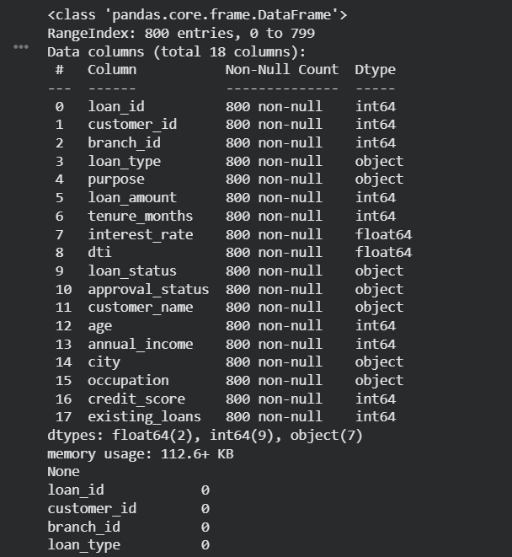
- Risk Features –
df["credit_band"] = pd.cut(
df["credit_score"],
bins=[0,599,679,749,900],
labels=["Poor","Fair","Good","Excellent"]
)
df["dti_band"] = pd.cut(
df["dti"],
bins=[-np.inf,0.35,0.50,np.inf],
labels=["Low","Medium","High"]
)
df["default_flag"] = (df["loan_status"] == "Defaulted").astype(int)
df["high_risk_flag"] = (
(df["credit_score"] < 600) |
(df["dti"] > 0.50) |
(df["default_flag"] == 1)
).astype(int)

- KPI Calculations –
approved = df[df["approval_status"]=="Approved"]
print("Approved loan value:", approved["loan_amount"].sum())
print("Default rate:", approved["default_flag"].mean())
print("Average DTI:", approved["dti"].mean())

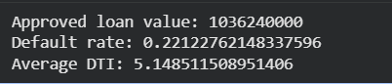
- Segment Analysis –
risk_by_credit = df.groupby("credit_band", observed=True).agg(
loans=("loan_id","count"),
default_rate=("default_flag","mean"),
avg_loan=("loan_amount","mean")
).reset_index()
print(risk_by_credit)

risk_by_type = df.groupby("loan_type").agg(
loans=("loan_id","count"),
portfolio_value=("loan_amount","sum"),
default_rate=("default_flag","mean")
).reset_index().sort_values("portfolio_value", ascending=False)

print(risk_by_type)

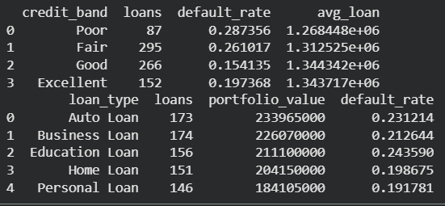

- Payment Analysis –
payment_summary = payments.groupby("loan_id").agg(
payments=("payment_id","count"),
avg_days_late=("days_late","mean"),
late_payments=("payment_status", lambda x: (x=="Late").sum())
).reset_index()
payment_summary["late_rate"] = payment_summary["late_payments"]/payment_summary["payments"]

df = df.merge(payment_summary, on="loan_id", how="left")

- Export Power BI Dataset –
df.to_csv(
"powerbi_loan_risk.csv",
index=False
)

payments.to_csv(
"powerbi_payments.csv",
index=False
)

- Chart Plotting –
df.to_csv(
"powerbi_loan_risk.csv",
index=False
)

payments.to_csv(
"powerbi_payments.csv",
index=False
)

